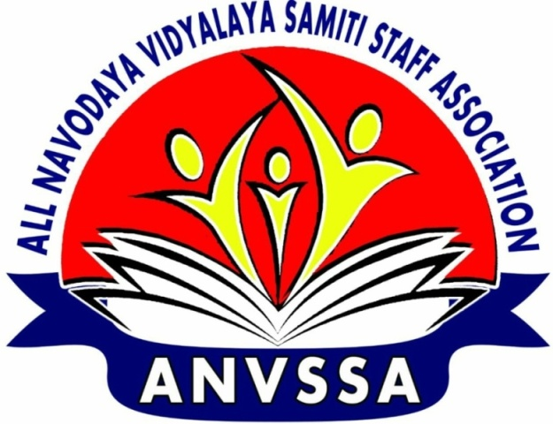
ALL NAVODAYA VIDYALAYA SAMITI STAFF ASSOCIATION (ANVSSA)
(Regd No: 639 of 2017)
President General Secretary
K. Manjula : 9494285645 Tafseer Anwer : 9935555002

F-ANVSSACEC/CCS PENSION/2018-19/AUGUST/69 Date:
Honourary President
L.B.REDDY
Legal Advisor
S.S.DORA
ASSOCIATE PRESIDENTS
N.P.MEHAR
K.M.REDDY
G.S.BASAVARAJU
U.K.VARMA

VICE PRESIDENTS
SHAIK MAROOF
HARIHAR RAI
K P. KORI
MRIDULCHAKRABORTY
DR. S.K.SINHA
P.K.MISHRA
R.S.RATHODE

DY GEN SECRETARIES
K.T.PRASAD
R.P.SHARMA
SHAMBHU PRASAD
U.G. SONPARKHE
SHAFI KAMAL

SECRETARIES
PRAHARAJ
SANJEEV KUMAR SINGH
S.K.ANANT
SOMNATH CHAKRABORTY
K.G.PRATIBHA
K.V.THOMAS
BHUVANESH KUMAR

REGNL ORG SEC
SAROJINI NADA GOWDA
RAVINDER KUMAR
R.K.MAGARIA
R.S.TOMAR
JYOTHI PANWAR
S.K.JHA
J.C.KONWAR
SITA RAM BANSAL

TREASURER
ZUBAIR ALI KHAN

PRESS SECRETARIES
- BRIJMOHAN MEENA
- A.K.JHA
To
Shri/Smt. ……………………………………….
Hon’ble Member of Parliament

Respected Sir
Sub: Grant of CCS pension to the staff of Navodaya Vidyalaya Samiti Request – Regarding.

Jawahar Navodaya Vidyalayas have occupied a niche in the field of secondary and senior secondary education in the last three decades thanks to selfless services of its employees. The NITI Aayog Report 2017 has also showered high praises on their functioning. Hon’ble Minister of HRD, Shri Prakash Javdekar, was also impressed by the stellar performance of the children, who come predominantly from rural areas. But we feel sorry to bring to your attention that the success of the JNVs has taken the attention of the Ministry of HRD and the Government of India from the plight of their employees.
Our demand for CCS Pension:
The Y.N.Chaturvedi Committee and 154th Parliamentary Standing Committees which studied the functioning of the Navodaya Vidylayas decried the discrimination meted out to the staff as they were denied the benefits of the CCS Pension 1972 scheme which should have been extended to them on a par with the staff of Kendriya Vidyalayas.VI CPC has also justified and recommended CCS Pension 1972 benefits to the staff of NVS.
The teaching and non-teaching staff also went on strike from 06-02-2013 to 15-02-2013 demanding the implementation of the CCS Pension Scheme 1972 and certain other legitimate problems. They have been deeply agitated as their post-retirement life is insecure. Accordingly, a Draft Cabinet Note was prepared and it has already been circulated among the concerned departments for approval. The Planning Commission and the DOPT have also positively responded to the Note.
Pension denied due the cut off date : The employees were denied the benefit on the grounds that the organization came into existence after the cut off date. The NVS was registered on 28-02-1986 but the cut off date for the old pension benefit happened to be 010-01-1986. The fact is that the Ministry of HRD got approval for setting up of two Model Schools, one at Amaravati (Maharastra) and another at Jajjar (Haryana), from the finance Ministry and notified the launching of them in October 1985 itself. Funds were released to NCERT, which was temporarily asked to monitor the schools till a suitable autonomous body was formed to run the schools on permanent basis.
The Government of India has introduced New Pension Scheme for those joining the service on or after
01-01-2004. But the 12580 teaching and non-teaching staff who joined the NVS before 01-01-2004, request the Government of India to treat their services on a par with their counterparts in the KVS and sanction the CCS pension 1972 benefits.
Through this letter the Association would like to request to use the services of your good office to bring the CCS Pension 1972 issue to the notice of Hon’ble Minister of HRD, Hon’ble Minister of Finance and Hon’ble Prime Minister at the earliest for an amicable and early resolution.
Your support to the staff will boost their morale and bring a qualitative change in the functioning of the vidyalayas.
Thanking you sir
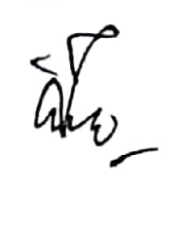
Yours sincerely
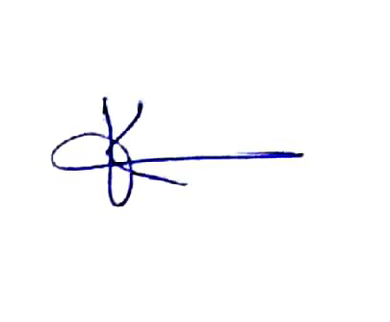

K.MANJULA TAFSEER ANWER
President General Secretary

